Research Proposal – Social Media Study among AUT International Students
- An introduction describing the topic area,
  - why you are interested in it,
I am an international student as all the others. When I first came to New Zealand, I don't know anyone here. Everything is new to me. Homesickness and study pressure made me feel like running away from New Zealand, and going back to my sweet home in China. The only way I can lighten the homesickness and alleviate the study pressure is to find new friends here and get to know the local cultures.
Social Networking softwares are very popular among young people, installed almost on every smartphone nowadays. With the modern SNS softwares, we can make dozens of 'friends' in a very short period.
There are many SNS softwares around the world, different region students have different preferences. Choosing the approapriate SNS software to make friends in AUT becomes an intresting question.
  - why it is relevant to others,
Every international student shall experience the same culture shock and homesickness as I do more or less.
  - what potential contribution it will make.
With the study/survey, we may achieve a basic idea what is the most popular SNS software in use in AUT international student, and what is the most efficient way to communicate with new friends.

- A critique of at least five journal articles related to your topic and/or your research method (about half a page each). A summary in a table could be very useful.
 | Title / Link | Description
1 | http://wearesocial.net/tag/statistics/  Digital, Social & Mobile Worldwide in 2015 | 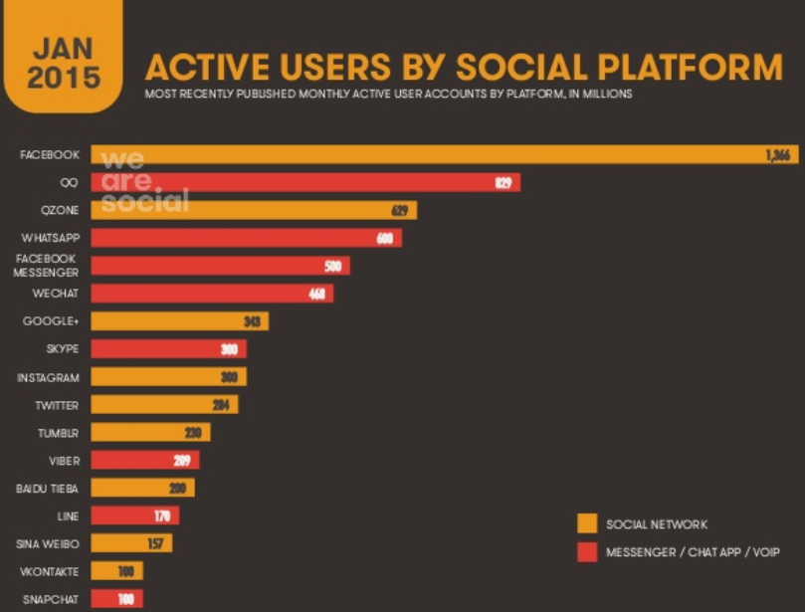
2 | http://www.sciencedirect.com.ezproxy.aut.ac.nz/science/article/pii/S0747563210002244  Online social networks: Why do students use facebook? | The growth and popularity of online social networks has created a new world of collaboration and communication. More than a billion individuals around the world are connected and networked together to create, collaborate, and contribute their knowledge and wisdom.
3 | Students' perceptions of Facebook for academic purpos | Facebook is the most popular Social Network Site (SNS) among college students. Despite the popularity and extensive use of Facebook by students, its use has not made significant inroads into classroom usage.  In this study, we seek to examine why this is the case and whether it would be worthwhile for faculty to invest the time to integrate Facebook into their teaching.
4 | Addictive Facebook Use among University Students | The Facebook has become an essential part of almost every university students' daily life, and while a large number of students seem to get benefits from use of the Facebook by exchanging information for educational goals, make friends, and other activities, the literature indicates that this social networking site can become addictive to some university students' users, which is one of the today's higher education matters.
5 | Students Who Use Facebook Get Lower Grades, Study Shows | London's Daily Mail reports that a team of psychologists studied 219 university students between the ages of 19 and 54, and found that those who use Facebook while they study -- or even have it running in the background -- get grades that are 20 percent lower than those who do not.
6 | Facebook Addiction among Malaysian Students | In this study,  we selected a sample of 441 students in Universiti Teknologi Malaysia as respondents. Results show that 47% of the participants were addicted to Facebook. This ratio is almost the same among postgraduate and undergraduate st  udents, and interestingly,  among Malaysian and non-Malaysian
7 | Use of Facebook: a case study of Singapore students' experience | This study uses a naturalistic case study wherein the students' decision to use Facebook is a personal decision and on a voluntarily basis; their participation is not a required or graded component. The specific objectives of the study are first, to examine Singapore students' motives for using Facebook; second, to investigate the types of friends they communicated with on Facebook; and third, to examine how students manage their privacy on the social networking site.
8 | Facebook vs study: Students struggle to stay focused because of lure of social media | SOCIAL media is a massive distraction from students' crucial study time, a study has found.  Data collected by national tutoring provider yourtutor.com.au shows students are concerned more than ever about social media distractions and are asking for study tips in order to stay focused.
9 | Friends and Relaxation: Key Factors of Undergraduate Students' WeChat Using | The result indicates: 1) Almost all of the respondents use WeChat every day, and 18.8% of them use WeChat more than 2 hours per day. 2) The influence of friends is a major factor in using WeChat among undergraduate students. The item "Most of my friends use WeChat and encourage me to use" and "WeChat helps me to keep in touch with friends"recorded the highest and second highest mean score (4 03; 3. 97). 3) WeChat is a good way to release stress and relaxation for undergraduate students. It brings them more laughter and joy. 4) Family has no significant influence on WeChat using, and only 10% of the respondents agree with the item "I often chat with strangers in WeChat".
10 | WeChat Helps Sell Phone | This shows WeChat is recognized by Chinese consumers as a shopping channel, JD said
11 | Nice little earner; Making money from WeCha | A study hows how WeChat make money
12 | Applications of Mobile Social Media: WeChat Among Academic Libraries in China | It explores the use of this emerging mobile app using the official WeChat accounts of the top 39 academic libraries in China. The findings indicate that approximately one third of the libraries use WeChat as a marketing tool to promote collections and services for users
13 | A Study on the Application of WeChat in ESP Training | A study to help the students to study English with the help of WeChat and QQ
14 | http://traverse.net.nz/2014-social-media-statistics/  2014 Social Media Statistics in New Zealand | For our little population of 4,365,113 we Kiwis do pretty well when it comes to being active online.  89% of New Zealander’s are currently online and 55% are active on Facebook.  Having sat pretty quiet for a long time, Google Plus has seen a growth of 20% in the last six months; this brings its usage up to 8% of active Kiwi users. Twitter is close by with a 15% growth, bringing this platform up to 6%.
15 | http://iab.org.nz/resources/item/comscore-jan-2014-who-uses-social-media-in-new-zealand  comScore Jan 2014: Who uses Social Media in New Zealand? | 2.8 million people accessed a social media site in New Zealand during November 2013. This category reached 94.6 percent of the total Kiwi internet audience. Facebook was the clear leader with 1.95 million unique visitors; more than double that of LinkedIn who came in second place with an audience of 798,000 unique visitors. In the past 12 months, however, LinkedIn displayed a strong growth (53 percent) with its population growing from 520,000 in December 2012 to 798,000 in November 2013. Blogger ranked in third position with 559,000 unique visitors that month.
16 | http://www.likeable.co.nz/social-media-statistics-the-number-of-facebook-linkedin-twitter-instagram-pinterest-users-in-new-zealand/  The Number Of Facebook, Linkedin, Twitter, Instagram & Pinterest Users In New Zealand | 1. Facebook users in NZ  2, 400,000 (as at august 2013)  2. Linkedin users in NZ  697,000 (as at august 2013)  3. Twitter users in NZ  368,000 (as at august 2013)
17 | http://www.roimarketing.co.nz/articles/social-media-marketshare-demographics-zealand/  Social Media Market Share & Demographics in New Zealand | Market Share  A recent study by Adcorp looked at the top social media networks by usage in July 2013. Unsurprisingly, the results showed that Facebook was leading the charge closely followed by LinkedIn and Twitter. The study also blended in blogging networks but we have not included them here.  Network Estimated Users Percentage of New Zealand’s Population Facebook 2,600,000 58.14% YouTube 2,499,372 55.89% LinkedIn 606,632 13.57% Twitter 331,313 7.41% Pinterest 251,830 5.63% Instagram 235,593 5.27%
18

- Give an overview of all the research required to investigate your topic area. Typically, you will choose a small part of this to do as your project. Perhaps, it is the first thing to do. Perhaps, it is the bit you can do. Give rationale for your decision.
A, I need to make a literature review of the above articles and newspapers, to have an overview of:
- How do local KIWI utilize the social media?
- What is the benefits and drawbacks of using the social media, based on the reseach on Facebook
- What is the usage of WeChat, specially for Chinese.
B, I want to create a questionaire for the international students around me. Say 160 classmates in 4 classes that I attend.
C, I can analyze the data collected to see the usage pattern of social media with the help of Data Mining techniques (maybe statistics is good enough).

- The research question. This may contain a number of sub-questions.
Here are a few questions in mind:
Q1: What is the most popular social media in local Kiwi, based on the current statistic data, Facebook is the dominant one;
Q2: What is the most popular social media in the group of international students? Maybe Facebook, maybe not;
Q3: What is the main usage of these social media? How much time do they spend on them?
Q4: Are these social media helpful to their daily life? How about the impact on their study?
Q5: What is the most popular social media among Chinese students? It is pretty clear that WeChat is the one.
Q6: How does WeChat help Chinese students here in NZ? In positive way or negative way? Any impact on their study?
Q7: How do Chinese students socialize with non-Chinese students or Kiwi? What is the biggest barrier between Chinese and non-Chinese students?
Q8:
- Research Method. A plan of action: what, where, who, why and how.
What – A questionnaire
Where – inside AUT, among the international students
who – all international students in my classes, around 160 students
why - ?
how – The initial idea is to print out the questionaire and take them to classes and ask their help to fill the form.
- A pilot test run of the method. This is almost always extremely useful in informing you on how to refine details of your method and its application. A pilot test can also be very useful in assisting you to refine and scope your research question. If you don’t consider a pilot test appropriate, consult with your supervisor.
A pilot interview has been conducted with 2 indian classmates, ~15 chinese students, 1 usa student, 1 brazil student, a German student.
For Chinese, almost +99% of them are using WeChat, only a few of them using Facebook, which is rarely used;
For non-Chinese, facebook is the dominant social platform, whatsApp is another one. All other kinds of platforms like Kik, Viber, Line, Skype etc are all used more or less.

The functionalities of Facebook, WeChat, Skype, WhatsApp, Line have been examined. One finding of that is: WeChat has everything in just one application, even more than all others. No wonder why WeChat is rulinig the social media marketplace.

The other finding is that WeChat is not known to most of non-Chinese students. When they were introduced with the functionalities of WeChat, they were all excited with it. But the problem is there is no friend is using it, basically they will not try it.

